

**Project Report**

**Topic: Driver’s Iris Tracker**

**Course: CSE499A**

**Section: 10**

**Group: 03**

**Submitted To:**

**Mohammad Ashrafuzzaman Khan**

**Submitted By:**

**Md. Asaduzzaman Sakib – 1521705642**

**Shawon Hawlader – 1520851642**

**Mitu Rani Das – 1512383642**

**Driver’s Iris Tracker**

**Introduction:**

Now a days accident has became very common all over the world. Due to lack of sleep and tiredness, accident can occur while driving. The best way to avoid accidents caused by driver is to detect whether the driver is sleepy or not and where he is watching by scanning his eyes.So that we can warn them. Bangladesh is a developing country with a very dense population of 160 million living in an area of 1,47,570 sq. km. The length of major roads in this country is about 21,269 km (BBS, 2010).Among this 3,538 km are national highways, 4,276 km are regional roads and 13,455 km are feeder roads. At least 2,329 people, including 291 women and 381 children, were killed and 4,361 others injured in 2,159 road accidents across Bangladesh in the first half of 2019.

**Objective:**

The objective is to overcome the problem related to the accidents related to drivers experiencing fatigue leads to a need arises to design a system that keeps the driver focused on the road.

**METHODOLOGY**

Prior to proposing a new hybrid method for the Iris detection, a thorough study is carried out on the existing methods of drowsiness driver detection mechanisms and they are listed at. A better hybrid version of Iris detection mechanism is expected to be proposed using the specifications, observations and calculations figured out in the theoretical study. Standard face detection techniques and heart rate variability analysis results were studied and they have been used to create a new fuzzy based hybrid Iris detection mechanism.

**The Idea:**

1. A video camera placed inside the car is continuously filming the driver’s face during the ride.
2. A detection system analyses the movie frame by frame and determines whether the driver’s eyes are open or shut.
3. If the eyes are shut for more than 1/4 a second (longer than a normal blink period) then the systems beeps to alert the driver.
4. Immediately the alarm will ring.

**Our Proposed Method:**

The proposed method is built in six stages and it is applied to the images with any background:

* Localization of Face
* Localization of the Eyes
* Tracking the eyes in the subsequent frames
* Detection of Drowsiness
* Tracking the face & detect 4-6 head position
* Detection of Distraction
* Left – Right Identify
* Gps Tracker
* Alarm

**General Flow of the Study and Implementation**

The general flow of the research can be mainly divided into several parts. In here eye detection model is proposed with the physiological and behavioral measurements of the subject. According to that the study varies mainly on these two sectors. Basic steps of the behavioral measurements are as follows,

* Study of behavioral techniques used to track eye.
* Video Acquisition.
* Extracting features to detect eye.
* Monitoring features with time.
* Providing output based on the detected features.

Basic steps of the physiological measures are as follows,

* Study on physiological measures used to detect eye..
* Selecting HRV analysis to detect eye..
* Analyzing LF/HF ratio for test samples.
* Selecting a suitable range of LF/HF for the implementation.

Using the two input variables finally a fuzzy model has been designed to predict the driver’s drowsiness level.

**Eye Shut Duration as Behavioral Measurement for Drowsiness Detection:**

After the thorough study of behavioral measurements to detect drowsiness, we selected eye shot duration of the driver as the behavioral measurement to detect drowsiness. To calculate the blink duration, the first thing we did was face detection. To do the face detection we use “harr cascade face detection mechanism”. To detect eye in the face we use “harr eye tracking algorithm”. To detect the eye shut duration we use the Hough circle detection mechanism.

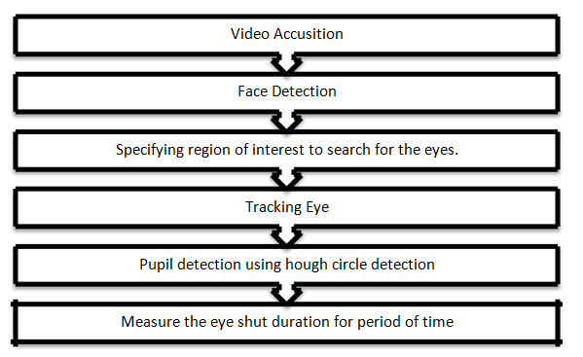

**Fig. 1: Basic Flow of Behavioral Measure**

Here the “haar face detection” and “haar eye tracking algorithm” were built in EmguCv library, and they were used to detect the face and the eye. To improve the eye searching mechanism, we give eye searching area the region of interest to search for the eyes as heuristics. This region of interest was selected by studying the normal human facial geometry.

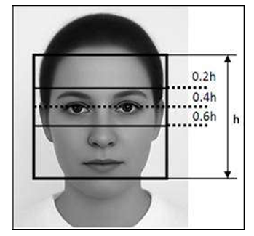

**Fig.2 : Rules of Human Face Proportions**

As shown in Figure 2 the human eyes are located in 0.2h to 0.6h heights from the top border of the facial area (When the total height of the face is h). This feature was used and given as an input to the eye detection algorithm . After detection of the eye, to detect the eyes open or shut the Hough circle detection was used. When the eye is in the open state iris can be detected by Hough circle detection. To improve the detection mechanism canny filters were used.

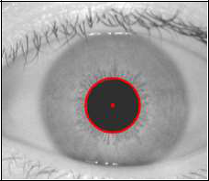

**Fig. 3: Iris Detection Using Hough circles**

**RESULT AND DISCUSSION**

The results of this experiment can be mainly divided into three subcategories, which are results from the physiological measurements, results from the behavioral measurements and result from the overall system.

**Results from Behavioral Measurements**

The basic face detection was done using haar face detection mechanism and Figure 10 show the basic detection of the face and facial features when eyes are open.

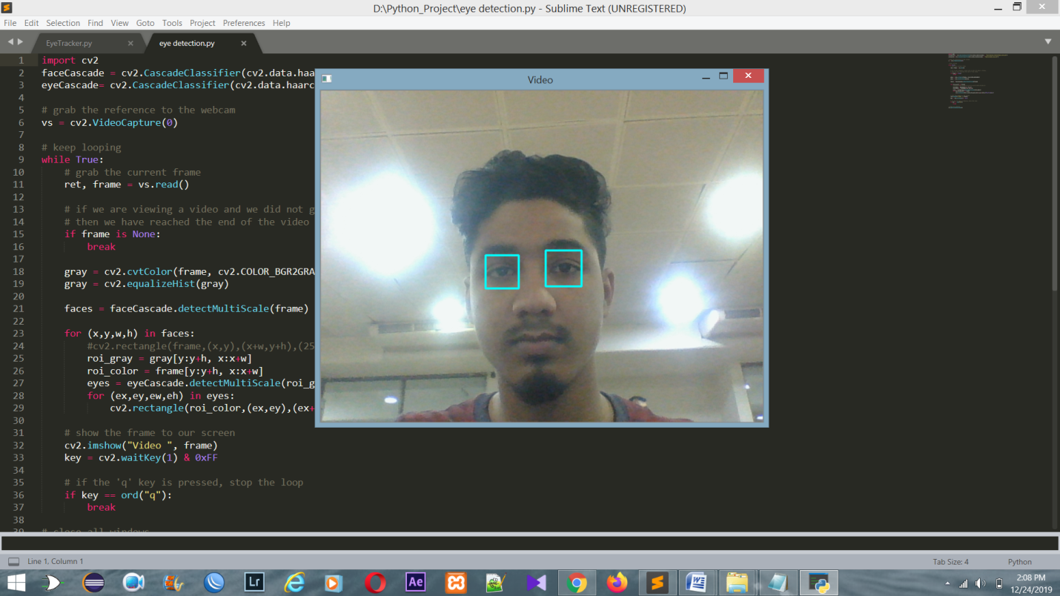

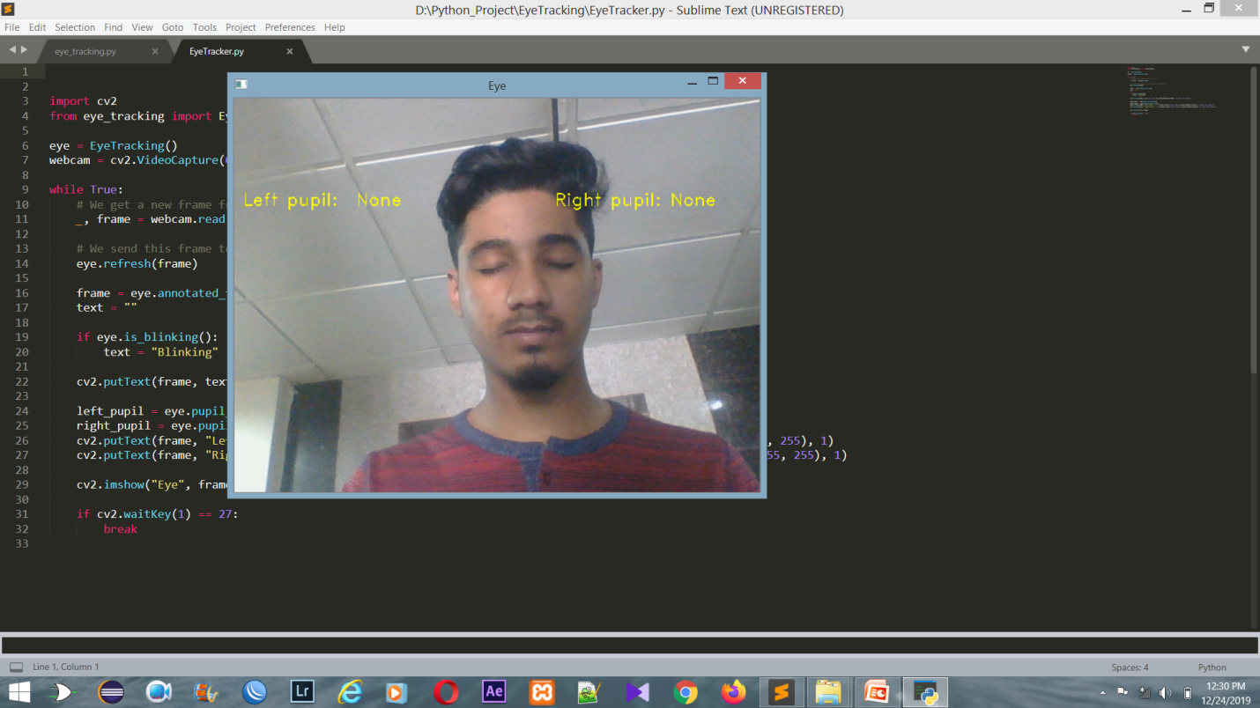

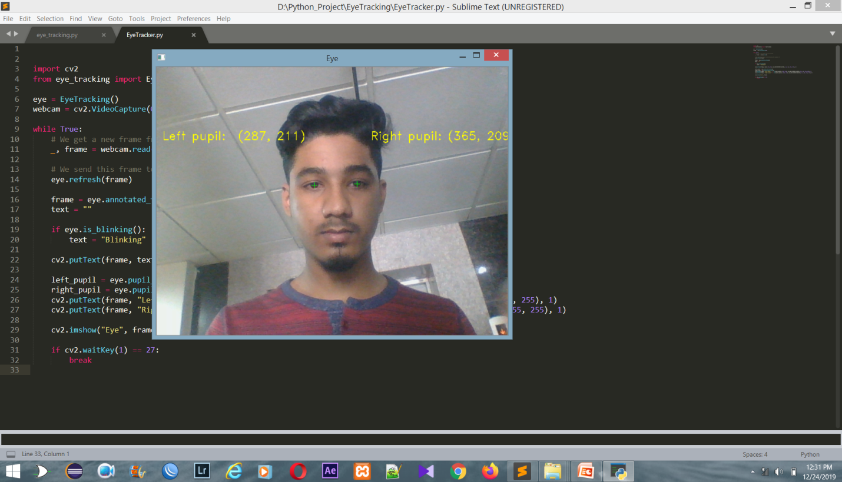

**Requirment:**

* Python
* Machine Learning
* Image Processing
* AI

**Conclution:**

The driver safety in the car is one of the most wanted system to avoid accidents. For enhancing the safety, we are detecting the eye blinks of the driver . The proposed system detecting drowsiness of driver by continuously monitoring mouth area & eyes.